**STOP/INTREPID Teleconference: Wednesday, August 2, 2023, 1:00-2:00 pm**

# Land Acknowledgment:

* Identify the land you are joining us from today ([**https://www.whose.land/en/**](https://www.whose.land/en/))
* Video: [Bringing meaning and purpose to land acknowledgements](https://www.facebook.com/CentreforAddictionandMentalHealth/videos/bringing-meaning-and-purpose-to-land-acknowledgements/759567845184040/)

Summary of July 5 meeting:

* STOP survey updates: race, immigrant status, transportation added to STOP baseline on July 15, 2023

Intrepid Lab Updates:

1. View the 1st edition of the [Intrepid Lab Newsletter](https://createsend.com/t/y-FBDE72523E55271B2540EF23F30FEDED)
   * We plan on releasing two newsletters each year
   * Please opt in to receive them: [**https://confirmsubscription.com/h/y/5901866DB84AF1E0**](https://confirmsubscription.com/h/y/5901866DB84AF1E0)

# TEACH Updates:

* Website: <https://www.nicotinedependenceclinic.com/en/teach>
* Courses: <https://teach.camhx.ca/moodle/> (a number of self-study courses are available)

1. [**Foundational Health Educator Workshop**](https://www.nicotinedependenceclinic.com/en/teach/foundational-health-education-course)

* September 11&12, 8:00 am-5:00 pm
* 1001 Queen St. W, Toronto ON, M6J 1H4
* $595 fee (*includes the cost of the required workbook and a lunch on both workshop days*)
* No prerequisites are required; requirement for the Certified Tobacco Educator (CTE) credential
* The core competencies of the work﻿shop include:
  1. Health Promotion and Education
  2. Communication (including motivational interviewing)
  3. Educational Interventions
  4. Resource Management
  5. Professional Practice
  6. Program Evaluation
* Register here: [FHE (September 2023) (camhx.ca)](https://teach.camhx.ca/moodle/enrol/index.php?id=98)

1. [**Tobacco Interventions for First Nations, Inuit and Métis Populations (August 2023)**](https://teach.camhx.ca/moodle/enrol/index.php?id=109)
   * August 23-September 27, 2023
   * $400 fee (13.5 h online course)
2. **What clinicians really need to know about vaping cessation among youth**
   * Wednesday, August 23, 2023 12:00-1:00 pm EST
   * Trisha Tulloch and Madelynn Hannah
   * Register [here](https://edc.camhx.ca/redcap/surveys/?s=KFR943CETKM37YTK)

# STOP Updates:

**PLEASE READ: STOP data partitioning v2.0:**

* As per our REB requirements, STOP *Program* records (August 27, 2022 and later enrollees) **should not** be stored alongside STOP *Study* records (August 26, 2022 and earlier enrollees). The STOP *Study* records must be kept in separate offline data based (CAMH Team access only)
* In order to fulfill these requirements while ensuring minimal interruptions to clinical care, the transfer of STOP *Study* data to the offline database is being done in two phases:

**Phase 1:** All ***completed*** study enrollments (any enrollees from July 28, 2021 and earlier). *We completed this on Oct 21, 2022.*

**Phase 2: Study enrollments from July 29, 2022 to August 26, 2022) will be transferred once their enrollment period is complete.** *This transfer scheduled for Sep 27, 2023. We will discuss it in depth at the September 6th teleconference*

Please see visual below for an overview of the data partitioning timelines.

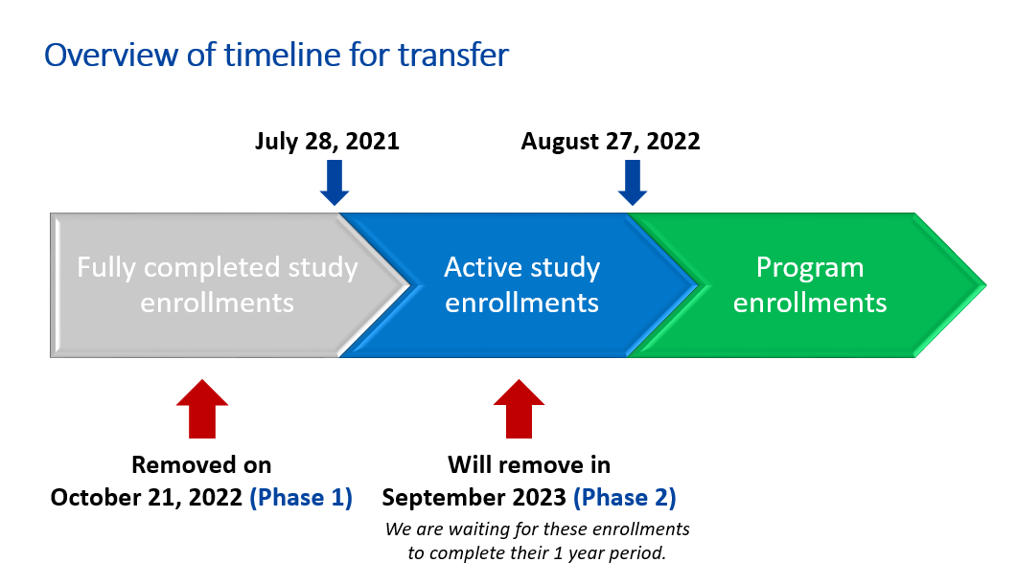

**What does this mean for you?**

* **As of September 27, 2023** all participants who enrolled on August 26, 2022 or earlier will no longer be accessible via the STOP Portal:
* This includes any visits/follow-ups tied to the participant’s enrollment (even if they took place after August 26, 2022)

**In the STOP Portal, these participants *will not be included* in:**

* Patient Searches
* Dashboard enrollment summary & list of recent encounters
* Feedback reports
* Note: NRT Order records on or before August 26, 2022 will be removed
* Note 2: Inventory Log section for old visits will remain available in a limited form – you will be able to see the NRT given out and date, but not the participant’s ID

**What can I do to prepare?**

* Your organization should download feedback reports for these data (July 29, 2021 – August 26, 2022 data will be removed)
  + Note: Feedback reports will continue to remain available in the STOP Portal for enrollments from August 27, 2022 onwards
* Count your inventory and make sure all visits are entered and all past orders are accepted!

STOP Data Partition Q&A:

**Q: If you want to download your client list prior to August 27, 2022 do the following:**

A: Patient/client search 🡪 enter your 3-digit site code followed by a hyphen in the ‘patient ID’ field 🡪 enter date range as desired 🡪 search

**Q: What if I need to access old STOP data after it’s been removed from the Portal?**

A: You can reach out to us as needed.

**Q: Do you foresee any additional data removal for the clients who remain on the STOP Portal *after* the upcoming data removal?**

A: This is not likely – the main reason we are removing these data (all data pertaining to enrollments before August 27, 2022) is because they pertain to ‘study’ participants. As no further ‘study’ participants will remain on the portal, there should not be a need to remove any further data.

**Q: Is it still a requirement to record clients as “R1-,” “R2-,” etc.?**

A: Please continue doing this if possible. If you cannot remember exactly whether someone should be R1-, R2-, etc., please use your best guess.

**Self-enroll page updates (“My STOP Portal”)** ([www.joinstopprogram.ca](http://www.joinstopprogram.ca))

* + Please feel free to share the revised email script below with anybody who is eligible and interested in self-enrolling in the 26-week STOP Program at your organization

***Subject Line: STOP Program – Invitation to Self-Enroll***

*Dear [First Name],*

*Thank you for your interest in the Smoking Treatment for Ontario Patients (STOP) Program.*

***To join the program, please go to*** [***www.joinstopprogram.ca***](http://www.joinstopprogram.ca) ***and follow the steps on the website.***

***IMPORTANT: Please use the exact link above to enroll. Do not search for STOP online.*** *There is another program called STOP on the Net which is* ***not*** *connected to your clinic and if you enroll in that program, you will not be able to join the program discussed with your health care practitioner.*

*For your reference, you can find a copy of the STOP Consent Form* [*here*](https://www.nicotinedependenceclinic.com/en/Documents/STOP%20Program%20Consent%20v16Aug2022.pdf)*. For frequently asked questions about the program,* [*click here*](https://www.nicotinedependenceclinic.com/en/stop/Pages/STOP-FAQ.aspx)*.*

*If you have any questions, please email us at* [*stop.support@camh.ca*](mailto:stop.support@camh.ca)*.*

*Regards,*

*The STOP Program*

* + Please remember that there are different URLs that are for different STOP-related programs:
    1. **26-week STOP program via Healthcare Practitioner:** 
       - [www.joinstopprogram.ca](http://www.joinstopprogram.ca) 🡪 this is where a patient goes to create with My STOP Portal account. This is the link that you (practitioner) shares with the patient.
       - [www.mystopportal.ca](http://www.mystopportal.ca) 🡪 once the patient has their My STOP Portal account (step above), they need to login using this link to complete their self-enrollment survey. This link is also provided in the patient’s account creation email, which is sent automatically to them.
    2. **STOP on the Net:**
       - [www.stoponthenet.ca](http://www.stoponthenet.ca) (8-week direct-to-patient program)

**STOP Operations Manual update**

* + Adding instructions for what to do in case of an NRT recall – will share updated manually with all sites when ready

**CAMH call display**

* As part of CAMH’s commitment to reducing the stigma associated with accessing mental health and addictions care, there is a change to CAMH’s call display identification effective immediately
  + Instead of CAMH appearing as a “Private Number”, *all calls originating from the hospital will now appear as “CAMH” or the Access CAMH/Switchboard phone number* depending on the network carrier
* Patients from your organization that receive STOP follow-up phone calls from CAMH will now show this on their call display

General Q&A:

**Q: Are follow-up surveys sent on the actual date of the 3-month, 6-month, and 12-month follow-ups? When do the calls occur?**

A:

* Scheduled automatically on 3-, 6- and 12-month dates from consent date (but uses previous day if necessary)
  + E.g., Jan 30 enrollment = April 30 (=1st day of 3-month follow-up)
  + But Jan 31 enrollment = April 30 (since April 31 is not valid)
* If patient provided an email:
  + Emailed on 1st, 4th, 7th and 10th day
  + Called up to 2-5 times from days 11-30 as necessary (note: we do not make any calls for 3-month follow-up surveys, these are email only)
* If patient did NOT provide an email:
  + Called up to 2-6 times form days 1-30 as necessary (note: we do not make any calls for 3-month follow-up surveys, these are email only)

**Q: Some practitioners are planning to call at 3 months to increase follow-ups and to encourage clients to return to the clinic if they have stopped coming. Are there scripts used for calling that can be sent to us?**

A:

*Below is the script we’ve provided our team for doing the follow up calls at 6 and 12 months:*

*Hello, may I please speak to __________(Participant name)?*

*This is _______ (staff first name).*

*I’m calling from the STOP Smoking Program.*

*You are participating through the  _______[organization name].*

*It’s time for your 6/12M follow-up, it takes just two minutes.*

**Q: Can questions about other forms of nicotine use (besides cigarettes) be added to the visit forms?**

A: Yes, we will be doing this once we have removed all pre-August 27, 2022 ‘study’ data from the STOP Portal.

**Q: In the meantime, is it okay to say they are smoking and figure out the approximate number of CPD?**

A: In cases like this, please do NOT estimate – answer the questions for cigarettes only (e.g., if the patient is ONLY using e-cigarettes, you would enter ‘0’ for cigarettes per day).

**Q: Do we still refer to the program as the STOP Program for clients? Will it change names now that it is not study-based?**

A: The program can still be referred to as the STOP Program.

News:

[New cigarette warning labels in effect this week aim to deter kids, convert parents](https://ca.finance.yahoo.com/news/cigarette-warning-labels-effect-week-080000103.html?guccounter=1)

[Stare at smokers to stop them, Hong Kong health chief urges public](https://www.bbc.com/news/world-asia-china-66206511?xtor=AL-72-%5Bpartner%5D-%5Byahoo.north.america%5D-%5Bheadline%5D-%5Bnews%5D-%5Bbizdev%5D-%5Bisapi%5D)

[London morning: publicly-funded drug rehab facility requested](https://www.cbc.ca/listen/live-radio/1-158-london-morning/clip/15999478-publicly-funded-drug-rehab-facility-requested)

[These Two Simple Exercises Can Help Lower Your Blood Pressure](https://ca.sports.yahoo.com/news/two-simple-exercises-help-lower-060003667.html?guccounter=1&guce_referrer=aHR0cHM6Ly93d3cuZ29vZ2xlLmNvbS8&guce_referrer_sig=AQAAAAKnWzXENldbCMwSUiQI5Li3jvg547Z7qrkxbZaFpTtq-kw4qeJAo1V2E5rYTDOxFbkWZGgoplFqy5scfxOkXXQZcpM1PnPx38pmmp74nF6JHNwjCquDTXRyWOkVoBNtkXTwKfgvhuecaoJPE6x_RZ5YtFYBI21IFMHl93Ebj1nM)

### Resources:

**STOP Practitioner Resources Webpage**:

[**https://www.nicotinedependenceclinic.com/en/stop/implementer-resources**](https://www.nicotinedependenceclinic.com/en/stop/implementer-resources)

# Quote of the day (STOP participant):

*Thank you for the chance to quit smoking with your program. I am coming up to 4 months smoke free!*

# 2023 teleconference schedule:

|  |  |  |  |
| --- | --- | --- | --- |
| ~~January 11~~ |  | ~~February 1~~ | ~~February 15~~ |
| ~~March 1~~ | ~~March 15~~ | ~~April 5~~ | ~~April 19~~ |
| ~~May 3~~ | ~~May 17~~ | ~~June 7~~ | ~~June 21~~ |
| ~~July 5~~ | ~~July 19 cancelled~~ | ~~August 2~~ | ~~August 16 cancelled~~ |
| **September 6** | September 20 | October 4 | October 18 |
| November 1 | November 15 | December 6 |  |

Fun Poll:

***What do you regret most?***

* *Something you did*  *23/62 = 37%*
* ***Something you didn't do 39/62 = 63%***

# Attendance:

Anishwabe Mushkiki AHAC

Algoma PHU

Algonquin FHT

AMHS-KFLA

Arnprior fht

Athens FHT

Bancroft FHT

Blue Sky FHT

Bridges CHC

Burlington FHT

Carea CHC

Carepoint CHC

Caroline FHT

Central Brampton FHT

Central Lambton FHT

Centretown CHC

Chatham-Kent FHT

Chatham-Kent PHU

CHIRS AMHA

City of Kawartha Lakes FHT

City of Lakes FHT

CMHA Huron Perth

CMHA Toronto

CMHA Windsor

Compass CHC

ConnectWell CHC

Cornwall Community AA

Couchiching FHT

Dufferin Area FHT

Englehart and District FHT

Fort William FHT

Georgian Bay FHT

Grand Bend Area CHC

Great Northern FHT

Guelph FHT

Haldimand FHT

Hamilton FHT

Hamilton PHU

Hamilton-Niagara CHC

Health for All FHT

Homewood Community AA

Humber River FHT

Huronia NPLC

Inner City FHT

Kawartha Lakes CHC

KFL&A PHU

Kingston CHC

Kirkland District FHT

Leeds and Grenville FHT

Leeds and Grenville PHU

Niagara North FHT

Niagara Region PHU

North Bay NPLC

North Durham FHT

North Huron FHT

North Muskoka NPLC

North Perth FHT

Northeastern Manitoulin FHT

Northumberland FHT

Northwestern PHU

Ontario Health

Ottawa Valley FHT

Owen Sound FHT

Parkdale CHC

Peterborough FHT

Prime Care FHT

Queen’s Square FHT

Sandy hill CHC

Scarborough A FHT

Simcoe Muskoka PHU

Six Nations AHAC

Smithville FHT

South Georgian Bay CHC

Sudbury PHU

Superior FHT

Taddle Creek FHT

Temagami FHT

Thames Valley FHT

Two Rivers FHT

Unison CHC

Upper Canada FHT

Wabano AHAC

Waasegiizhig AHAC

West Champlain FHT

West Elgin CHC

Woodbine FHT

Women’s College Hospital FHT